Question 1. Previous research has suggested that positive mood makes people more patient, but it was not known if negative emotions had the opposite effect. Lerner et al. (2013) hypothesized that sadness would increase impatience. All participants watched a 3-minute movie clip and wrote an essay as a mood manipulation, and then performed a financial decision task to choose between an immediate and delayed reward. To create a sad mood, participants watched a movie clip about the death of a boy’s mentor and wrote an essay about a time when they were sad. In the neutral condition, participants watched a nature clip about the Great Barrier Reef and wrote an essay about their recent activities. Participants were randomly assigned to one of the mood conditions. After the mood manipulation, participants were given a series of 5 choices between small, immediate cash rewards (e.g., $10 now) or larger delayed rewards (e.g., $20 in a month). The total amount of the rewards selected was scored with a lower total value indicating a preference for immediate rewards over future rewards. Participants in the sad mood condition tended to select the smaller, more immediate rewards more often than the participants in the neutral condition.

1. What construct is intended to be operationally defined as the independent variable? Describe the independent variable.
2. What construct is intended to be operationally defined as the dependent variable? Describe the dependent variable with respect to the hypothesis.
3. There is a possible an alternate interpretation of these data based on the idea that the dependent variable may be measuring something other than the intended construct. What else could be being measured here by the DV as implemented?

Question 1 continued.

1. Here are some hypothetical data that might have come from this study. The values are the average amount of money chosen by participants in each condition.

|  |  |  |  |
| --- | --- | --- | --- |
| Condition | Mean | SD | SE |
| Neutral | 56.5 | 18.20 | 4.07 |
| Sad | 35.8 | 18.77 | 4.20 |

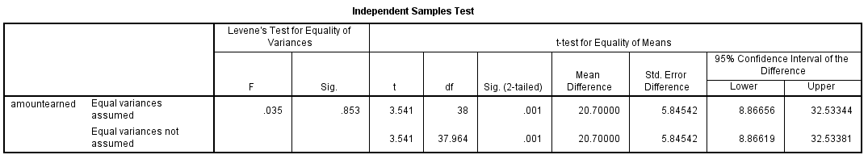

What type of analysis did the authors use to evaluate the effect of the IV on the DV (be as specific as you can)? Was it statistically significant (yes/no) and how do you know?

1. Write out the results statements that describe the data. Include both descriptive and inferential statistics in the standard APA format.
2. Because people can differ a lot in how patient they are overall, the experimenters want to replicate this study using a within-subjects design. List two potential concerns about switching to a within-subjects design for this study, and then propose a solution to each of the concerns that would allow the experimenters to conduct the within-subjects experiment effectively.
3. From an ethics standpoint, what are the problems that would be caused if the researchers running the study failed to clearly indicate that the rewards were hypothetical, and all participants would be paid exactly $15 for participation immediately at the end of the study. List 2-3 relevant research ethics principles.

1. Researchers attempting to replicate the study at NU found the same pattern of results, but it was discovered that the data had accidentally been collected such that all the sad mood manipulation participants were run right before the big school fundraiser (e.g. Dance Marathon) weekend, and the students were short of their fundraising goals. Does this confound the results of the NU study? If it does, give an alternate explanation for the results that would change the conclusion from this study.

Question 2. Definitions.

Fill in the blanks with the appropriate terms:

____________________ The section of an APA-style research report where the author draws conclusions and integrates the study results with the existing experimental literature.

____________________ A type of experiment where both the experimenters and the participants do not know what condition the participants are in.

____________________ An experiment has __________ if we can be certain that the changes in behavior are actually caused by the independent variable as opposed to other unrelated variables.

____________________ The technique of assigning participants to conditions such that each participant has an equal chance of being assigned to each treatment condition.

____________________ The ethics principle that every human being is an autonomous person who has the right to make an informed decision about their participation in research. The notion of informed consent comes from this principle.

____________________ The hypothesis that the dependent variable does not change as a result of different levels of the independent variable.

____________________ A condition where a group does not receive any intervention at all.

____________________ A university committee that reviews proposed research and safeguards the rights of human participants.

____________________ Change in subjects’ performance over time due to participants’ learning and familiarity with the task.

____________________ An error made when experimenters say that significant differences between treatments were produced by the independent variable even though it really had little or no effect.

Question 3. John, Blunden, and Liu (2019) wanted to test the hypotheses that people tend to “shoot the messenger” meaning they dislike the bearers of bad news even when the messenger did not cause the bad thing to happen. They had participants consider the following scenario in an online experiment:

One week ago, you received a biopsy to test for skin cancer. The results are now in, so you are called into your medical clinic. Your nurse, Nurse Johnson, tells you: “I have bad [good] news: your biopsy tested positive [negative]. This means that the mole is [NOT] cancerous.”

Participants were randomly assigned to receive either the bad or good news version of the scenario before being asked to rate the nurse using the statement “I like Nurse Johnson on a scale from 1 (*strongly disagree*) to 9 (*strongly agree*)”.

1. Describe the outcome (data) that would support the hypothesis in terms of the experimental IV and DV.
2. An alternate explanation for findings supporting the hypothesis is that the imagined bad news made the participants tend to dislike everybody, not just the messenger who delivered the bad news. A factorial design can be used to provide a better test of the hypothesis by adding a ‘bystander’. In addition, in a follow-up experiment it was decided to change the good news/bad news scenario being used:

Imagine you are a participant in a cooking competition show and you’ve made it to the finals and really want to win the prize. You’ve submitted your final dish and are waiting for the announcement of the outcome. The Host is waiting with you and the other finalist when the Assistant Host comes out with the result. The camera zooms in on you and the Assistant Host announces “The results are in and… you are [not] the winner! Congratulations on winning [second place]!”

The rating question can now be answered with the same scale about either the Host of the show (bystander) or the Assistant Host who delivered the good/bad news. Explain the two factors (independent variables) and their levels in this design. You may use a diagram to answer this question if you would like.

1. Describe the hypotheses tested by the part of the analysis (ANOVA) that evaluates the two main effects for this study.
2. Consider a finding that there was an interaction between the IVs such that the bad news caused the participants to give lower liking ratings to both hosts, but particularly the Assistant Host. Fill in the graph below showing how these data might appear visually.

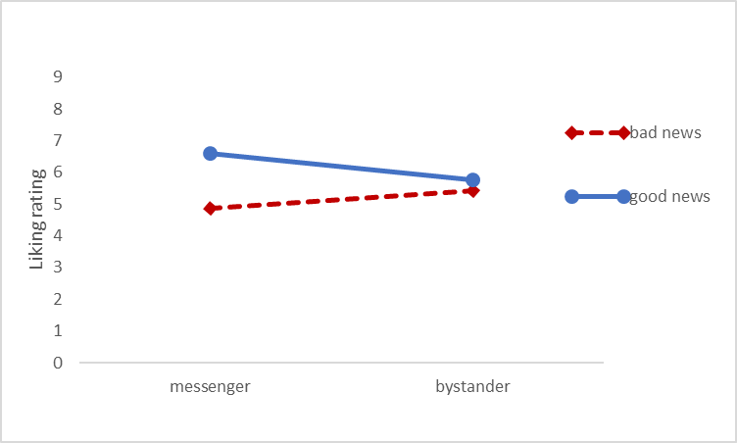

1. How does using a different scenario for the good news/bad news story in the second experiment affect the interpretation of the results of the study with respect to the intended construct (messengers bringing good or bad news)?
2. This experiment was run online, which means the experimenters have generally much less control over external variables. List 2 external variables that might affect the results of a study like this. Explain whether these are likely to cause a Type I (false positive) or Type II (false negative) error.
3. How could you run a study along these lines in a laboratory context? Describe how you could operationally define new versions of both of the factors (independent variables) in a study you could run here at NU. You may also modify the dependent variable for your new design if you wish. In addition to describing your procedure, note any ethical issues you would need to explain to the IRB about your hypothetical study.

